After running the PROCESS version 3.4 macro, I used the following code provided by Professor Wuensch:

title1 'Potthoff'; run;

Proc Format; Value gr 1='Experimental' 0='Control'; run;

data Potthoff; infile 'C:\Potthoff-06.dat'; input Group Time Exam Interaction; Format Group gr. ; run;

Proc Standard Mean = 0 STD = 1 Out = Zs; Var Time Exam; run;

proc sgplot; reg x = Time y = Exam / group = Group; run;

proc reg data=Zs PLOTS=none; model Exam = Group Time Interaction; TEST Group=0, Interaction=0;

Title1 "Test of Coincidence"; run; QUIT;

Proc GLM data=Zs PLOTS=NONE; Class Group; Model Exam = Time Group / ss3; LSMeans Group; Title1 "ANCOV"; run; QUIT;

Title1 "Process";

%process (data=Zs,y=Exam,x=Time,w=Group,model=1,jn=1,plot=1);

Proc Ttest plots=none; Class Group; Var Exam; Title1 "T-Test"; run;

proc corr nosimple; var Time; with Exam; Title1 "Correlation"; run;

Output is as follows:

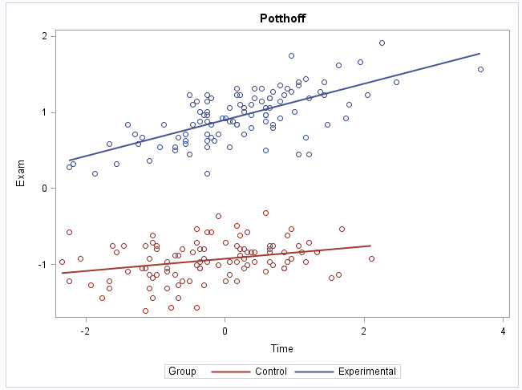

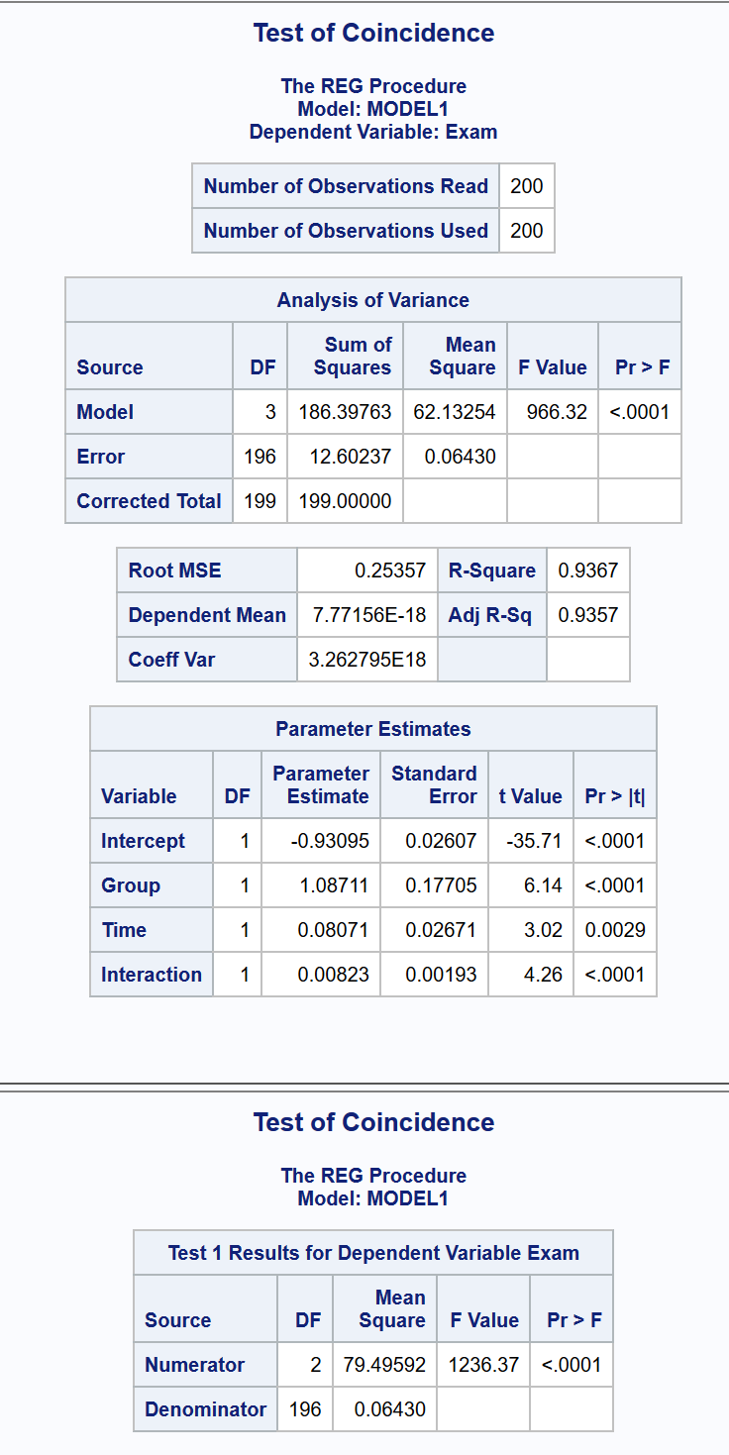

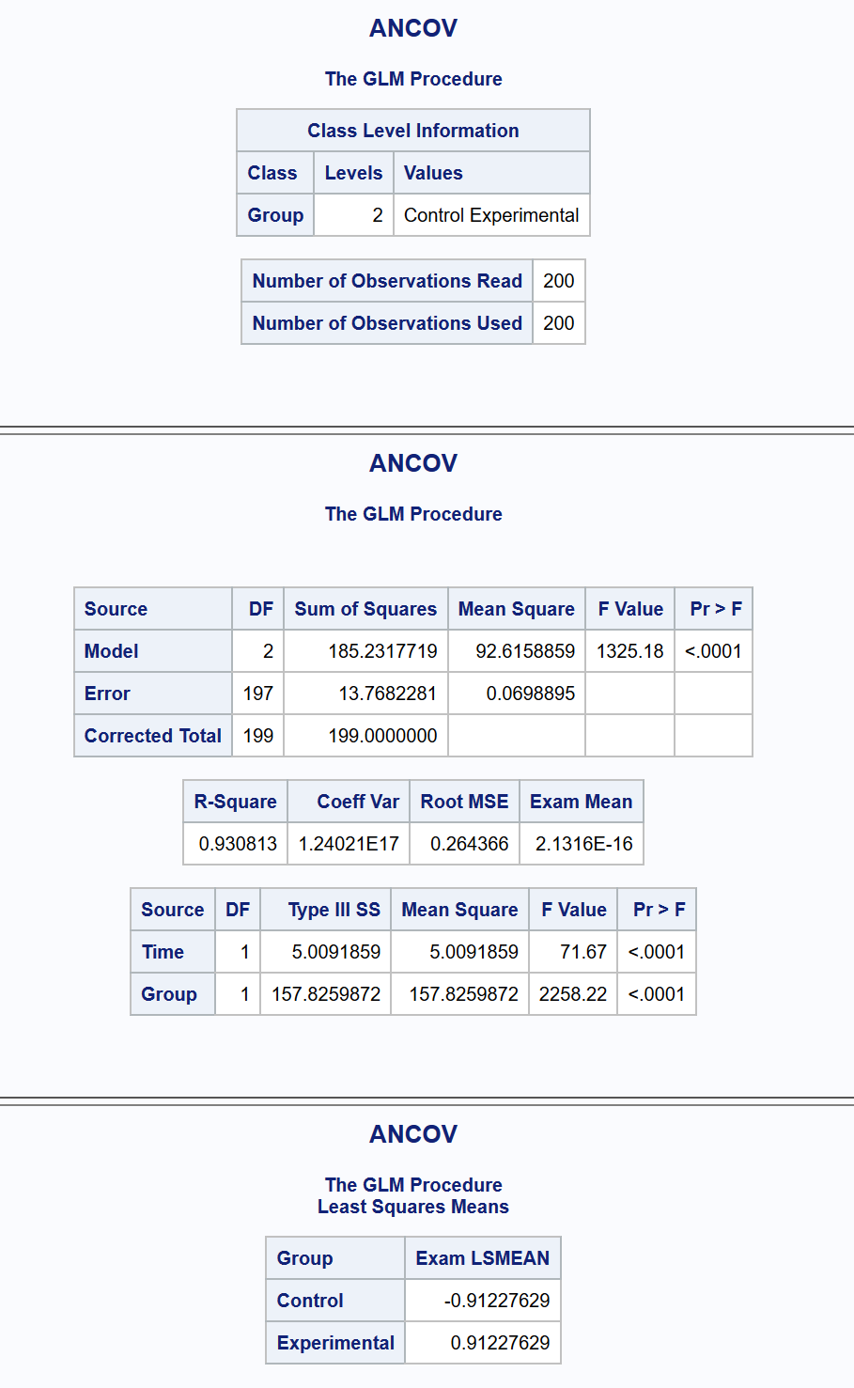

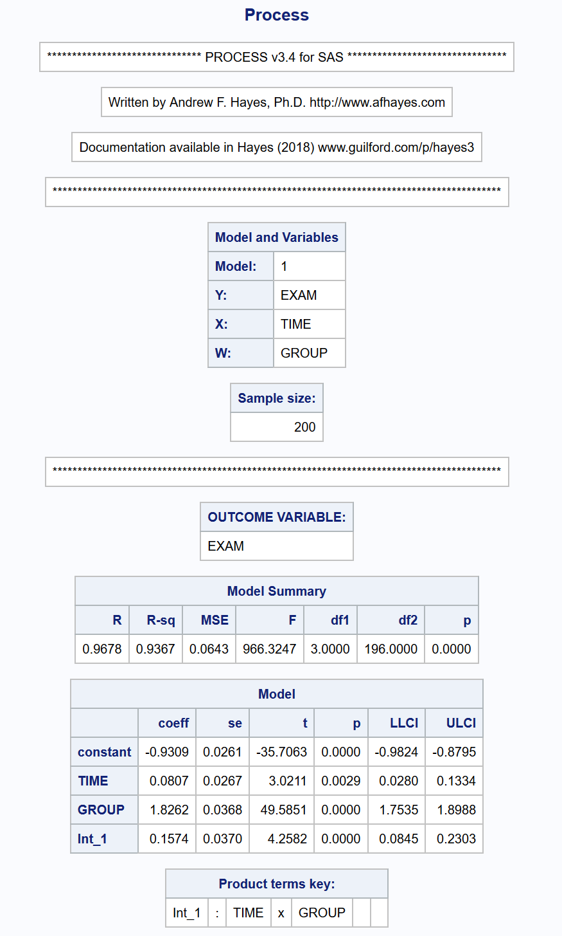

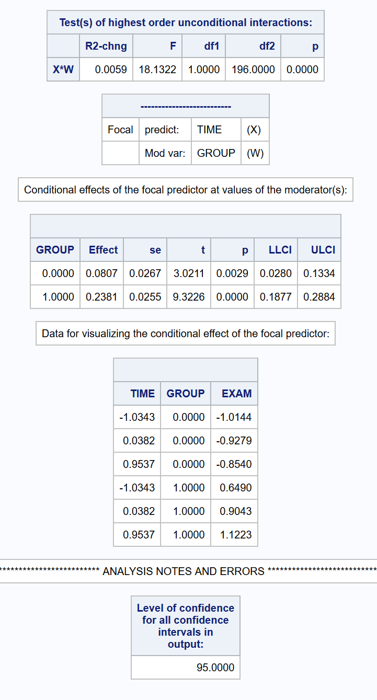

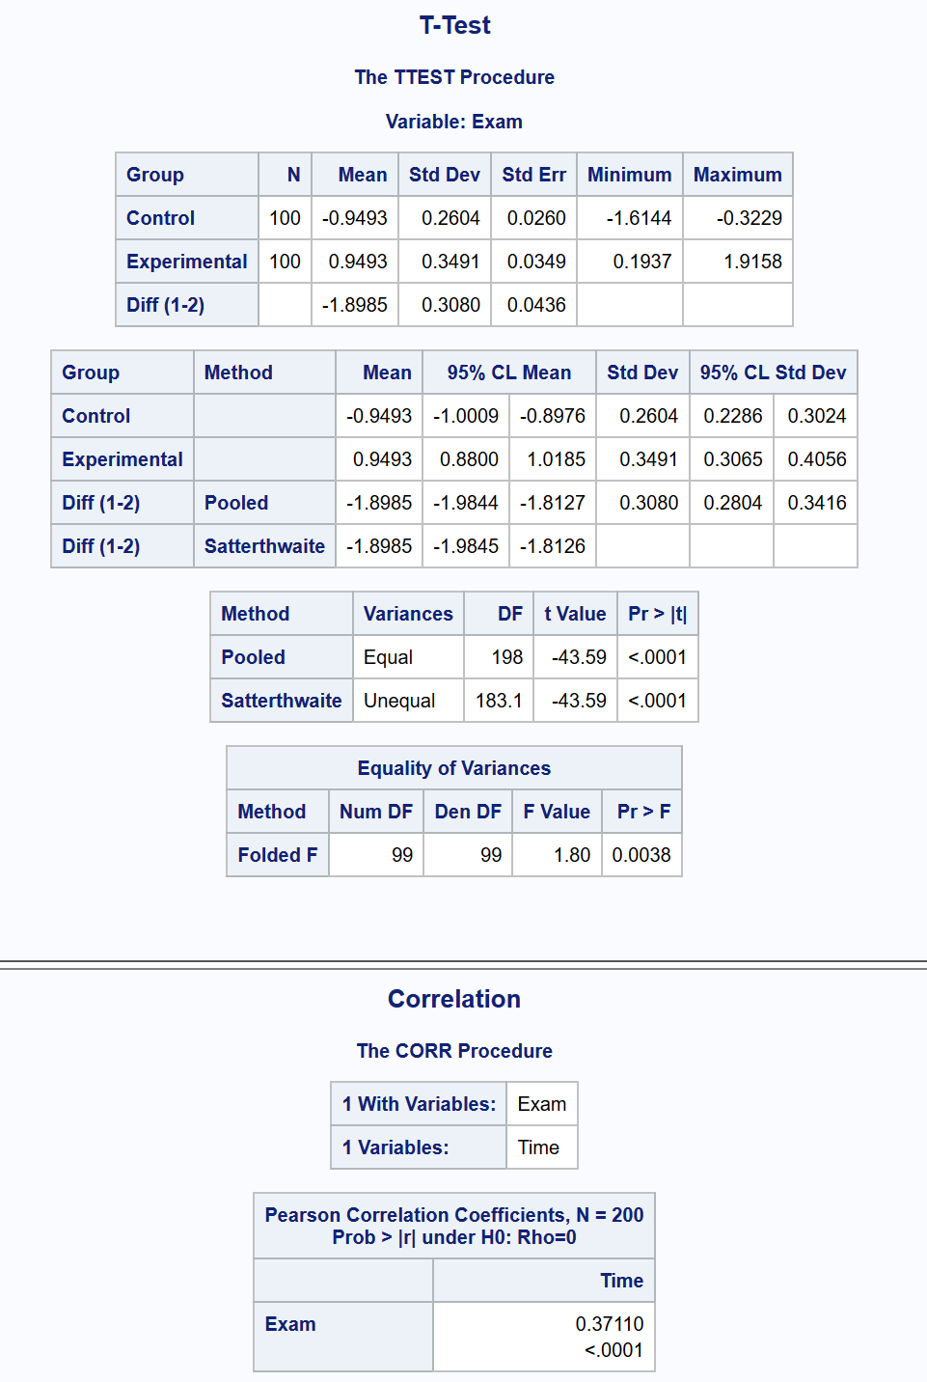

I did also attempt the assignment in R. In the submitted report, I used the interaction scatterplot generated by GGplot2:

1. Assign value labels

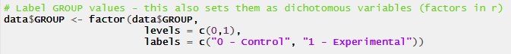

2. Standardize continuous variables

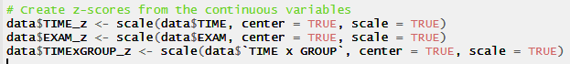

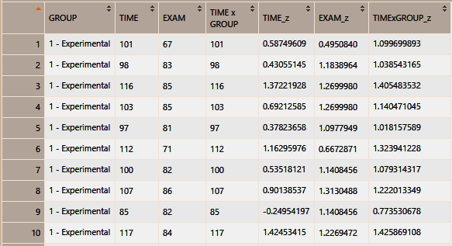

3. Prepare interaction scatterplot



